Assessment 1: Stock Volatility Prediction
Mathias Henry Morgan
35087056

Project Introduction
The overall idea taken in this project as to apply three well known tree-based models to this volatility prediction regression task. The decision was taken to use tree-based models due to their tendency to perform well on tabular and structured data, tree based can capture non-linear patterns, are relatively robust to outlier values and have in built feature selection logic through pruning, regularization and ensemble methods which partially reduces the need to feature selection prior to applying the models. This project employs three tree-based ensemble models, Light GBM, Cat Boost, and Random Forest to predict future stock volatility in a regression framework.
Models
Light GBM: Light GBM (Light Gradient Boosting Machine) is an efficient gradient boosting algorithm widely employed in supervised learning for regression and classification tasks. It constructs an ensemble of decision trees through iterative training, each new tree is fitted to minimize the residual errors of previous trees. Light GBM uses a leaf-wise tree growth strategy, which prioritizes expanding the leaf node that produces the greatest reduction in loss at each step. This approach facilitates the construction of deeper, more expressive trees. Furthermore, Light GBM offers native support for categorical features, eliminating the need for one-hot encoding. It also incorporates effective pruning mechanisms and regularization via which reduce the influence of low-information features and mitigate overfitting.
CatBoost: CatBoost (Categorical Boosting) is a gradient boosting algorithm developed by Yandex, optimized for supervised learning tasks involving mixed data types. It builds an ensemble of decision trees iteratively, where each new tree corrects the prediction errors of the previous ones using gradient descent. Unlike most models that require one-hot encoding for categories, CatBoost processes categorical variables natively through ordered target encoding a statistically sound method that replaces categories with numerical values based on target statistics while avoiding data leakage via random permutations during training. This makes preprocessing minimal and reduces overfitting risk. Additionally, CatBoost uses oblivious decision trees which improves prediction speed and regularization. It also implements ordered boosting, a technique that trains on random data permutations to prevent bias from target leakage in gradient estimation.
Random Forest: Random Forest is a robust ensemble learning algorithm widely used for regression and classification tasks on structured data. It constructs a multitude of decision trees during training and outputs the average prediction of the individual trees, thereby reducing variance and enhancing generalization. Each tree is grown on a bootstrap sample of the training data, and at each split, only a random subset of features is considered, further a major advantage of Random Forest is resilient to outliers due to rank-based splitting. While individual trees may overfit, the ensemble averaging, combined with constraints, acts as an effective regularization mechanism. Random forests do not accommodate categorical variables like the other models therefore one hot encoding is needed to pre-process the data.
EDA & Data Transformation
The initial phase of the project involved Exploratory Data Analysis (EDA) to assess the quality, structure, and suitability of the raw dataset for predictive modelling. This step is fundamental in any data science workflow, as it ensures that subsequent modelling efforts are built on suitable data. basic dataset characteristics were systematically examined, including the total number of observations, column metadata, presence of duplicate records, and missing or null values. These checks revealed a clean dataset with no duplicate rows and no missing values across all features and target variables, confirming that the data was complete and consistent in its raw form.
With the underlying data examined and determined to be suitable the following data transformation/feature engineering steps were take:
Volatility log transformation: This is an important step in the financial modelling process as it stabilizes and normalises the distribution of volatility which in this case is high skewed, essentially raw volatility contains mostly small values with occasional large ones as volatility expands and contracts across assets. As this is the target feature this step was critical to normalise for the models to train on. Below is a visual example of the raw and process volatility.
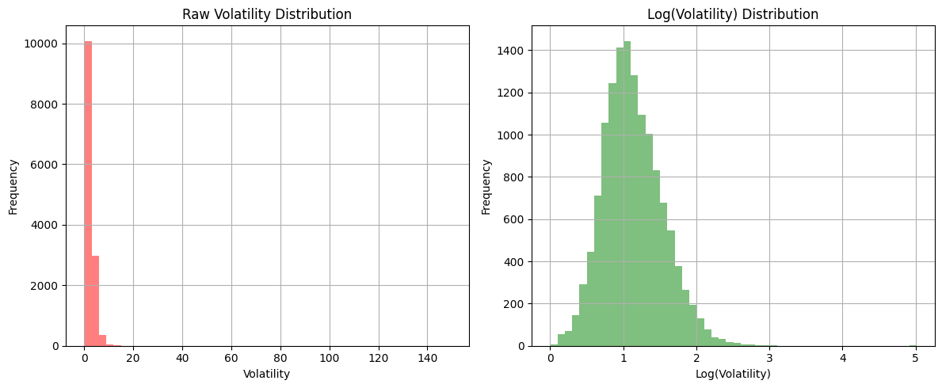
Cyclical Encoding: Cyclical encoding was applied to the date field to create sine and cosine transformations, this step essential because raw monthly values are ordinal and not continuous, the sine and cos transformations allow machine learning models to learn seasonal and time-based patterns as they are geometrically based.
Lagged Feature Engineering: lag feature engineering was applied to multiple features ranging from 1 to 3 periods corresponding to 1 to 3 months, this was done to capture temporal dependencies to allow the models to capture momentum, trends and how values can change over time in the future. Essentially the lagged features allow the models to understand the relationship between past and future values. For volatility especially it was important to create 3 separate features lagged 1, 2 to 3. Since the chosen models use some sort of pruning, they were able to determine which would give the best results.
Moving Averages and Exponential Moving Averages

Feature Importance & Correlation

Shvartz, E. (2021, October 12). Why tree-based models beat deep learning on tabular data. *Geek Culture*. https://medium.com/geekculture/why-tree-based-models-beat-deep-learning-on-tabular-data-fcad692b1456
GeeksforGeeks. (2024, October 10). LightGBM (light gradient boosting machine). https://www.geeksforgeeks.org/machine-learning/lightgbm-light-gradient-boosting-machine/
GeeksforGeeks. (2024, October 10). LightGBM (light gradient boosting machine). https://www.geeksforgeeks.org/machine-learning/lightgbm-light-gradient-boosting-machine/
GeeksforGeeks. (2025, April 15). CatBoost in machine learning. https://www.geeksforgeeks.org/machine-learning/catboost-ml/
GeeksforGeeks. (2025, September 1). Random Forest Regression in Python. https://www.geeksforgeeks.org/machine-learning/random-forest-regression-in-python/
GeeksforGeeks. (2025, July 23). How to remove non-stationarity in time series forecasting. https://www.geeksforgeeks.org/machine-learning/how-to-remove-non-stationarity-in-time-series-forecasting/
Kumar, A. (2023, March 14). Cyclical encoding: An alternative to one-hot encoding for time series features. *Towards Data Science*. https://towardsdatascience.com/cyclical-encoding-an-alternative-to-one-hot-encoding-for-time-series-features-4db46248ebba
Kumar, A. (2023, March 14). Cyclical encoding: An alternative to one-hot encoding for time series features. *Towards Data Science*. https://towardsdatascience.com/cyclical-encoding-an-alternative-to-one-hot-encoding-for-time-series-features-4db46248ebba

